**Report on**

**Credit Card Management System**

**Database Management and Database Design**

**Spring 2018**

**By**

**Bhagyashree Dinkar Patil**

**INDEX**

|  |  |  |
| --- | --- | --- |
| **Sr. No.** | **Topic** | **Page No.** |
| 1 | ER-DIAGRAM FOR CREDIT CARD TRANSACTION SYSTEM | 3 |
| 2 | CREDIT CARD TRANSACTION SYSTEM | 4 |
| 3 | VIEW | 5 |
| 4 | STORED PROCEDURES | 7 |
| 5 | TRIGGER FOR EMAIL VALIDATION | 9 |
| 6 | TRIGGER TO TRACK OF DELETED CREDIT CARDS | 10 |
| 7 | TRANSACTION | 12 |
| 8 | ACESS PRIVILAGES | 14 |
| 9 | MYSQL TABLES | 16 |
| 10 | MYSQL Dump DATABASE | 20 |

**ER DIAGRAM ON CREDIT CARD MANAGEMENT SYSTEM**

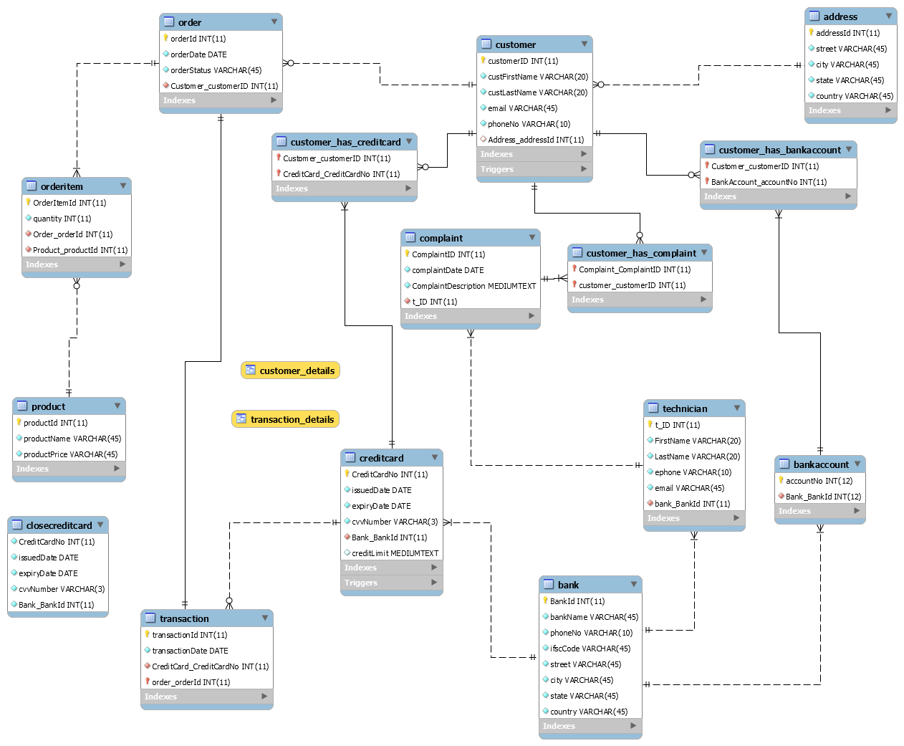

Fig1.ER diagram of credit card transaction system

**CREDIT CARD MANGEMENT SYSTEM**

**Problem Statement:** Create Database for credit card transaction system and to show relationships between different entity involved in it.

**Approach:** In credit card transaction system different Bank has many credit cards. Bank and creditcard has one-to-many cardinality. Customer can have zero or more credit cards of different banks. Each credit card has zero or more transactions. Each transaction contains Order. Each Order contains OrderItem. Each orderItem contains Product details. Bank has also technicians who solves customers complaints about creditcard.

**Creditcard transaction system has following entity type**

1. BANK
2. BANKACCOUNT
3. CREDITCARD
4. CUSTOMER
5. ADDRESS
6. CUSTOMER_HAS_BANKACCOUNT (Associative entity)
7. CUSTOMER_HAS_CREDITCARD (Associative entity)
8. TRANSACTION
9. ORDER
10. ORDERITEM
11. PRODUCT
12. TECHNICIAN
13. COMPLAINT
14. CUSTOMER_HAS_COMPLAINT (Associative entity)

.

**VIEW**

Delimiter $$

CREATE VIEW **Transaction_Details**

AS

select customerid, custFirstName, custLastName, email, customer.phoneNo, address.city, bankName,

customer_has_creditcard.CreditCard_CreditCardNo as creditCardNo,creditlimit,transactionDate,transaction.Order_orderId as

orderid,productName,productPrice,quantity,orderStatus

from customer inner join address on customer.customerID=address.addressId inner join

customer_has_creditcard on customer.customerID=customer_has_creditcard.Customer_customerID inner join

creditcard on customer_has_creditcard.CreditCard_CreditCardNo=creditcard.CreditCardNo inner join

bank on creditcard.Bank_BankId=bank.BankId inner join

`transaction` on creditcard.CreditCardNo=`transaction`.CreditCard_CreditCardNo inner join

`order` on customer.customerID=`order`.Customer_customerID inner join orderitem on `order`.orderId=orderitem.Order_orderId

inner join product on orderitem.Product_productId=product.productId;

$$

SELECT * FROM Transaction_Details;

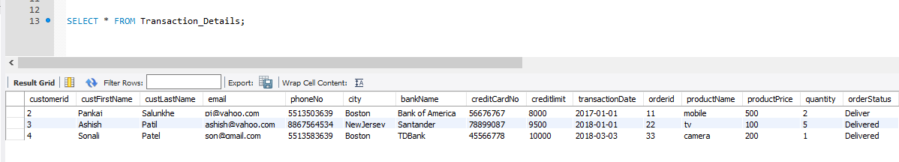

**STORED PROCEDURES**

DELIMITER $$

CREATE procedure ADDRESS_UPDATE(IN street1 VARCHAR(45),IN city1 varchar(45), IN state1 varchar(45), IN country1 varchar(45),IN id int)

BEGIN

UPDATE Address SET street=street1 AND city=city1 AND state=state1 AND country=country1 where addressId=id;

END;

$$

----------------------------------Address table before procedure call-----------------------------

select * from address;

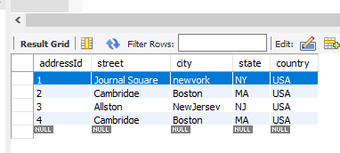

----------------------------- Address table after procedure call-----------------------------------------

call ADDRESS_UPDATE ('MGRoad','Chicago','Illinois','USA',1);

select * from address;

(On execution of address_update() procedure address is updated where is equal to 1)

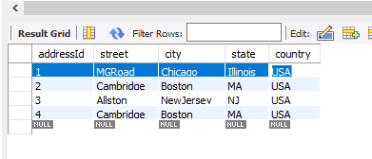

**TRIGGER FOR EMAIL VALIDATION**

DELIMITER $$

CREATE TRIGGER email_validation

BEFORE INSERT

ON Customer

FOR EACH ROW

BEGIN

IF new.email NOT LIKE '%_@%_.__%'

THEN

SIGNAL SQLSTATE VALUE '45000'

SET MESSAGE_TEXT ='Invalid email id';

END IF;

END;

$$

insert into customer (custFirstName, custLastName, email, phoneNo, address_addressid) values('Karishma','Patil','676767@@@@','8867564534',2);

C:\Users\bhagy\AppData\Local\Microsoft\Windows\INetCache\Content.Word\t2.png

TRIGGER TO TRACK OF DELETED CREDIT CARDS

CREATE TABLE CloseCreditCard (

CreditCardNo INT NOT NULL,

issuedDate DATE NOT NULL,

expiryDate DATE NOT NULL,

cvvNumber VARCHAR(3) NOT NULL,

Bank_BankId INT NOT NULL);

DELIMITER $$

CREATE TRIGGER CreditCard_Delete_Backup

AFTER DELETE

ON creditcard

FOR EACH ROW

BEGIN

insert into CloseCreditCard values(old.CreditCardNo,old.issuedDate,old.expiryDate,old.cvvNumber,old. Bank_BankId);

END;

$$

select * from creditcard;

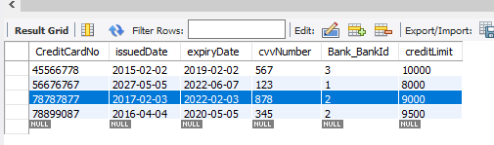

delete from creditcard where cvvNumber=878;

(Record having cvv number 878 deleted from **creditcard** table)

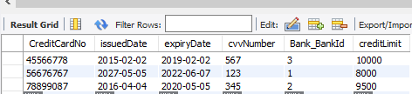

select * from CloseCreditCard;

(Record deleted from **creditcard** table is inserted into CloseCreditCard table)

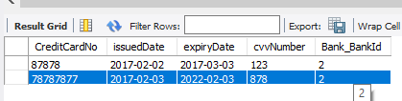

**TRANSACTION T1**

SET TRANSACTION ISOLATION LEVEL READ COMMITTED;

SET SQL_SAFE_UPDATES=0;

START transaction;

update Transaction_Details set creditlimit=creditlimit-(quantity*productprice) where orderid in(select orderid from `order` inner join customer on

customer.customerid=`order`.customer_customerID);

DO SLEEP(20);

COMMIT;

-------------------------------credit card table before transaction update-----------------------------------

SELECT * FROM CREDITCARD;

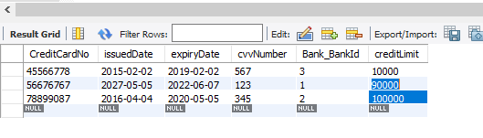

---------------------------- credit card table after transaction update--------------------------------------

(creditlimit in **creditcard** table updated after T1 execution)

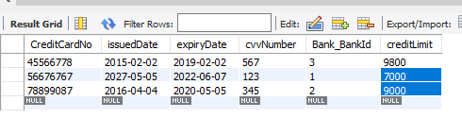

**TRANSACTION T2**

SET TRANSACTION ISOLATION LEVEL serializable;

SET SQL_SAFE_UPDATES=0;

START transaction;

SELECT CREDITLIMIT FROM CREDITCARD;

COMMIT;

-----------------------------T2 is waiting for completion of T1--------------------------------------

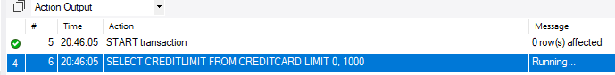

**Insert privileges to customer in customer table**

- create a new user

create user 'customer3'@'localhost' identified by 'customer3';

-- to check all the users existing in db

select user from mysql.user;

-- login as newly created user, no databases shown because of privileges

GRANT INSERT (custFirstName, custLastName, email, phoneNo) ON creditcardtransactiondb.customer TO 'customer3'@'localhost' identified by 'customer3';

C:\Users\bhagy\AppData\Local\Microsoft\Windows\INetCache\Content.Word\ap7.png

GRANT INSERT (street, city, state, country) ON creditcardtransactiondb.address TO 'customer3'@'localhost' identified by 'customer3';

C:\Users\bhagy\AppData\Local\Microsoft\Windows\INetCache\Content.Word\ap8.png

**Select access privilege to admin**

create user 'BankAdmin'@'localhost' identified by 'BankAdmin';

select user from mysql.user;

GRANT select ON creditcardtransactiondb.* TO 'BankAdmin'@'localhost' identified by 'BankAdmin';

C:\Users\bhagy\AppData\Local\Microsoft\Windows\INetCache\Content.Word\ap9.png

**select access privilege to technician**

create user 'technician'@'localhost' identified by 'technician';

select user from mysql.user;

GRANT select (complaintID,complaintDate,complaintDescription) ON creditcardtransactiondb.complaint

TO 'technician'@'localhost' identified by 'technician';

C:\Users\bhagy\AppData\Local\Microsoft\Windows\INetCache\Content.Word\ap10.png

**MySQL Database**

**Address table**

"addressId";"street";"city";"state";"country"

1;"Journal Square";"newyork";"NY";"USA"

2;"Cambridge";"Boston";"MA";"USA"

3;"Allston";"NewJersey";"NJ";"USA"

4;"Cambridge";"Boston";"MA";"USA"

5;"Allston";"Chicago";"Illinoise";"USA"

7;"PorterStreet";"Boston";"MA";"USA"

**Bank Table**

"BankId";"bankName";"phoneNo";"ifscCode";"street";"city";"state";"country"

1;"Bank of America";"9850445975";"23456";"Allston";"Boston";"MA";"USA"

2;"Santander";"8878888888";"78676";"Cambridge";"Boston";"MA";"USA"

3;"TDBank";"8989898989";"6756";"Journal square";"New Jersey";"NJ";"USA"

**BankAccount Table**

"accountNo";"Bank_BankId"

8989898;1

6677889;2

5555555;3

**CloseCreditCard Table**

"CreditCardNo";"issuedDate";"expiryDate";"cvvNumber";"Bank_BankId"

87878;"2017-02-02";"2017-03-03";"123";2

78787877;"2017-02-03";"2022-02-03";"878";2

98798798;"2012-05-05";"2020-06-06";"987";3

**Complaint Table**

"ComplaintID";"complaintDate";"ComplaintDescription";"t_ID"

201;"2018-02-02";"unauthorize use";111

**Creditcard Table**

"CreditCardNo";"issuedDate";"expiryDate";"cvvNumber";"Bank_BankId";"creditLimit"

45566778;"2015-02-02";"2019-02-02";"567";3;"8800"

56676767;"2027-05-05";"2022-06-07";"123";1;"7000"

78899087;"2016-04-04";"2020-05-05";"345";2;"9500"

**Customer Table**

"customerID";"custFirstName";"custLastName";"email";"phoneNo";"Address_addressId"

1;"Bhagyashree";"Patil";"56565";"9850445975";1

2;"Pankaj";"Salunkhe";"pj@yahoo.com";"5513503639";1

3;"Ashish";"Patil";"ashish@yahoo.com";"8867564534";2

4;"Sonali";"Patel";"son@gmail.com";"5513583639";3

24;"Minal";"Jadhav";"min@yahoo.com";"8787878778";3

26;"Pinu";"Shinde";"p@gmail.com";"9878677889";0

**Customer_has_BankAccount Table**

"Customer_customerID";"BankAccount_accountNo"

4;5555555

3;6677889

2;8989898

**Cutomer_has_Complaint Table**

"Complaint_ComplaintID";"customer_customerID"

201;2

**Customer_has_Creditcard Table**

"Customer_customerID";"CreditCard_CreditCardNo"

4;45566778

2;56676767

3;78899087

**Order Table**

"orderId";"orderDate";"orderStatus";"Customer_customerID"

11;"2017-01-01";"Deliver";2

22;"2018-02-02";"Delivered";3

33;"2016-02-02";"Delivered";4

**OrderItem Table**

"OrderItemId";"quantity";"Order_orderId";"Product_productId"

111;2;11;101

222;5;22;102

333;1;33;103

**Product Table**

"productId";"productName";"productPrice"

101;"mobile";"500"

102;"tv";"100"

103;"camera";"200"

**Transaction**

"transactionId";"transactionDate";"CreditCard_CreditCardNo";"Order_orderId"

1;"2017-01-01";56676767;11

2;"2018-01-01";78899087;22

3;"2018-03-03";45566778;33

**Technician Table**

"t_ID";"FirstName";"LastName";"ephone";"email";"bank_BankId"

111;"Rashmi";"Patel";"9898989898";"r@gmail.com";1